

**UNIVERSITY OF PETROLEUM & ENERGY STUDIES**

**Dehradun**

**CONTINOUS INTEGRATION**

**AND**

**CONTINOUS DELIVERY**

**Experiment**

**Name: Rakshit Kapoor**

**Course: B. TECH CSE DevOps (2018-22)**

**Roll no.: R171218082**

**Sapid: 500067642**

**Experiment-8**

**Implementing Master/Slave Architecture in Jenkins**

**Step-1:** Start and login to Jenkins

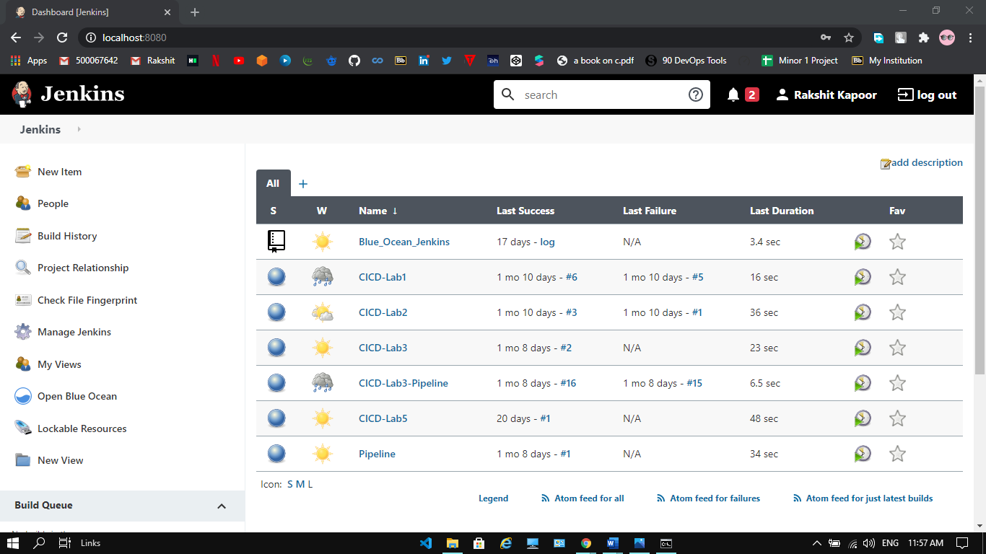

**Step-2:** Select the Option manage Jenkin and go to Manage Nodes and Cloud. Click on New Node. Provide path of Root Directory. Click on OK.

Your Slave will be created.

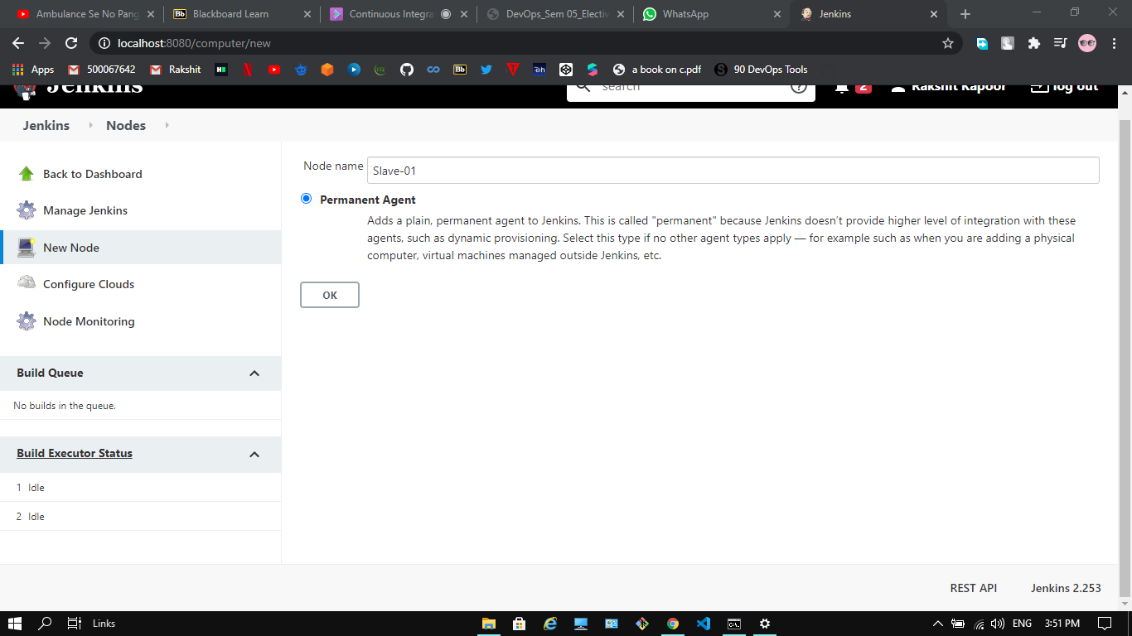

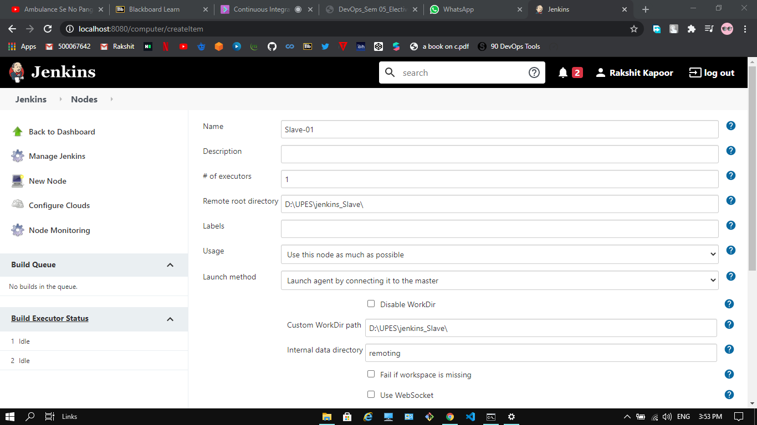

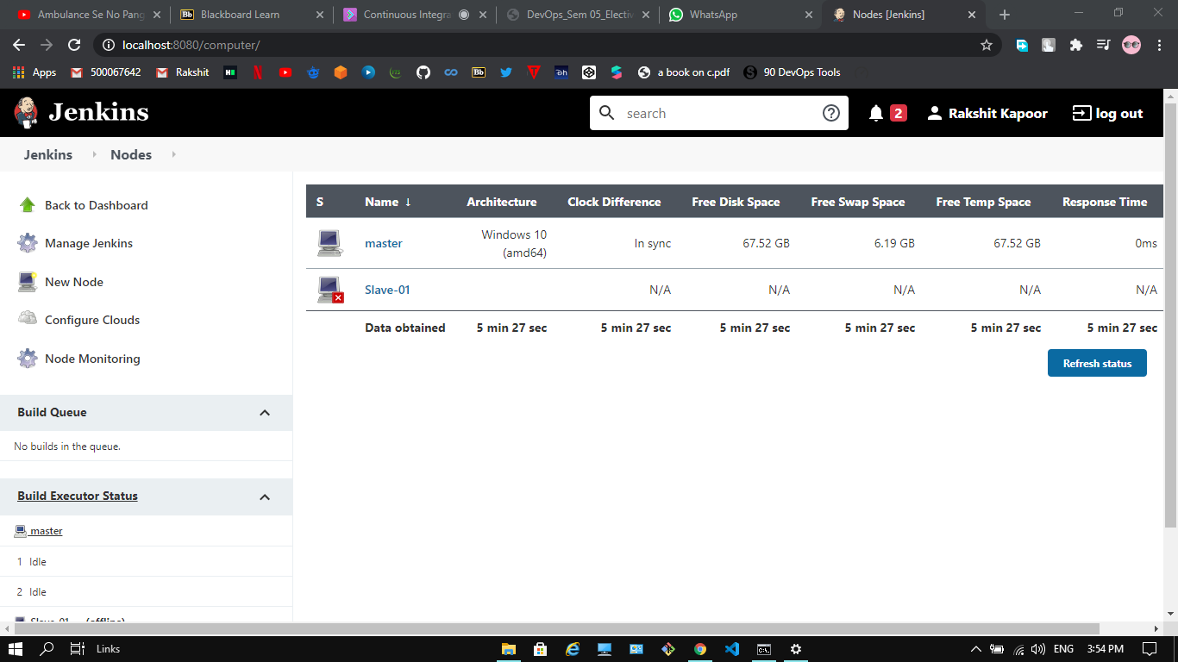

**Step-3:** Open the folder created for the slave node “Slave-01”. A new jar file “agent.jar” should be created. Copy the location of the directory where the agent.jar file is created.

**Step-4:** Traverse to the location of agent.jar. Run the command provided for “Slave-01” in its configuration settings. The agent “Slave-01” starts to run.

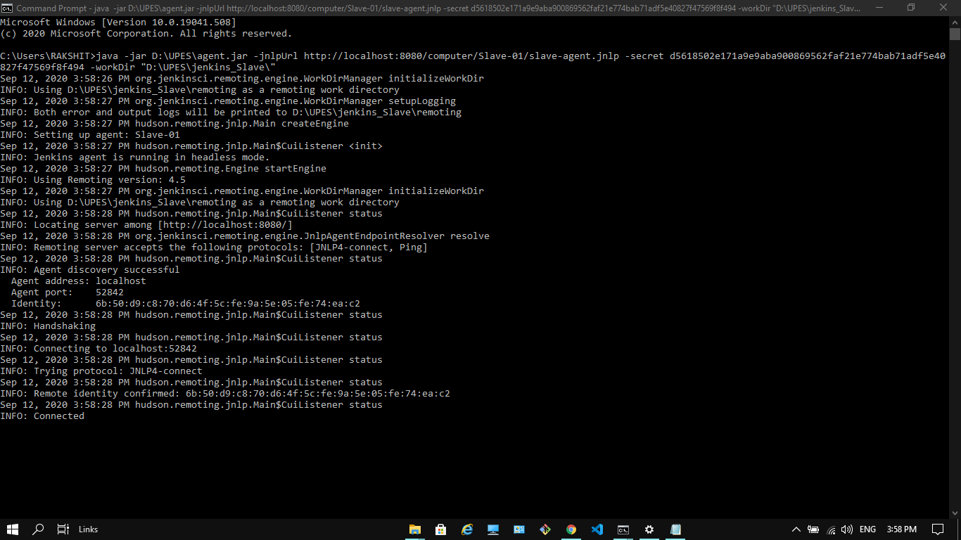

**Step-5:** Initially the node “Slave 1” showed it was inactive. It was marked by the red cross accompanying it. Now it is active

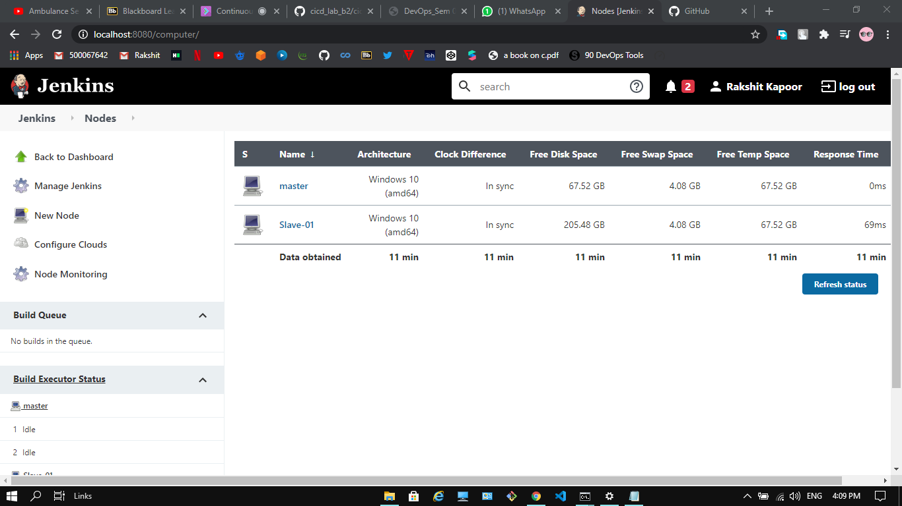

**Step-6:** Go to the configurations of an existing maven project. Go its “General” configurations. Check the option “Restrict where this project can run”. Provide the name of the slave node “Slave-01” in the label expression. Click on the “Build Now” option for the project. Select the console output to see the build process.



